How Insert/Update row using Lookup Transformation.

Create SSIS package using lookup transformation.  
1. Reading all data from excel and load into destination table without any modification.

Excel Source

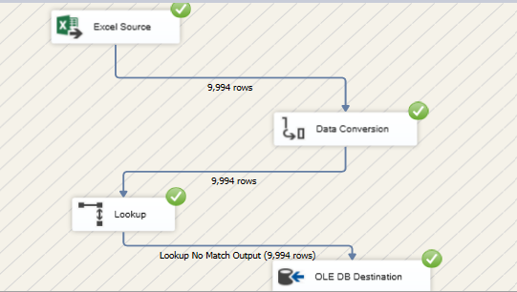

After executing the same package again by making changes in the last 2 rows we can get the following output that only the changed 2 rows are inserted into the database.

2. Read all data from excel/flat file and load into destination table using any modification.

**

After the execution

